**Problem 5.6**

Code to come up with sketches.

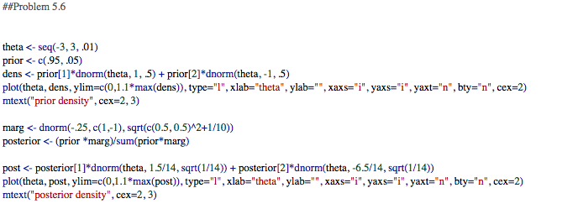

**Problem 5.11**

**Part b**

Contour Plot for Transformed Marginal Distribution:

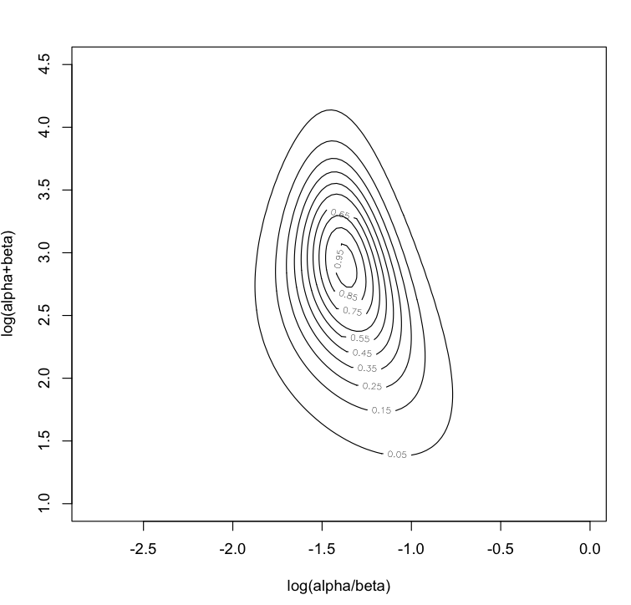

Code for Contour Plot:

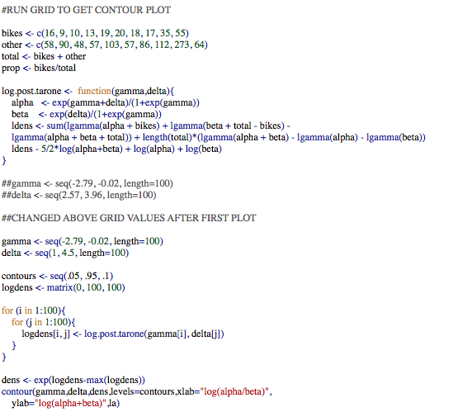

Code for Simulated Values from Joint Posterior Distribution:

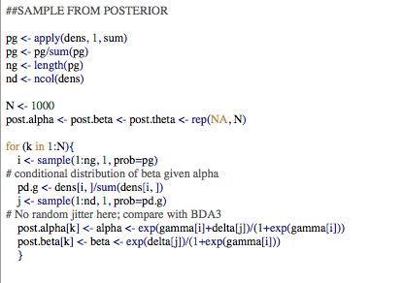

Code for simulation of parameters of theta will come in later parts.

**Part c**

The table below gives the raw proportion and the mean of the posterior proportion. The inferences for the posterior of the mean behave as expected. The posterior proportion is higher than low raw proportions and lower than high raw proportions. In other words, the posterior is correcting raw proportions that are too low or too high compared to the known data and bringing them closer to the average.

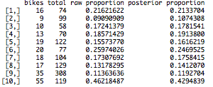

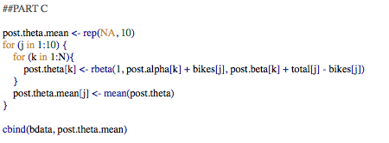

**Part d**

The 95% posterior interval for the average underlying proportion of traffic that is bicycles is given below.



Here is the code to produce the 95% posterior interval.

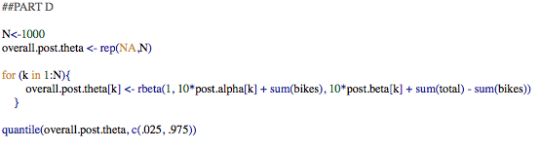

**Part e**

The 95% posterior interval for the number of vehicles for the observed block is given below. The posterior interval appears to be trustworthy as the interval below would give a proportion of .11 to .27, which captures 8 out of the 10 raw proportions. Therefore, this posterior interval seems to fit what we’ve seen in previous data.



Here is the code, which uses the simulated values of theta based on all the data (see code for Part d).

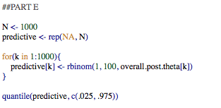

**Part f**

Yes, the beta distribution seems to be reasonable. All the intervals produced in the previous parts seem reasonable and the beta distribution is typically the reasonable model to use when trying to predict a parameter that is a proportion from 0 to 1.

**Simulation Problem 5**

Below is the code for the requested R function that simulates from the truncated Poisson for a specified k and lambda, and generates a histogram, bar plot, and the approximate mean and variance.

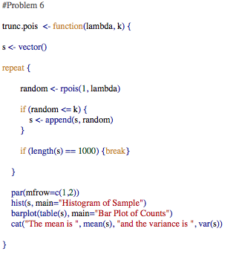

The approximate mean and variance of the truncated Poisson can be calculated for any lambda when k=10 using the function above. While I am not analytically giving the approximate mean and variance, the code is sufficient because it can work for any lambda.

For example, here is the output for k=10 when lambda equals 8. The console prints the following and the histogram and bar plot graphs are produced.



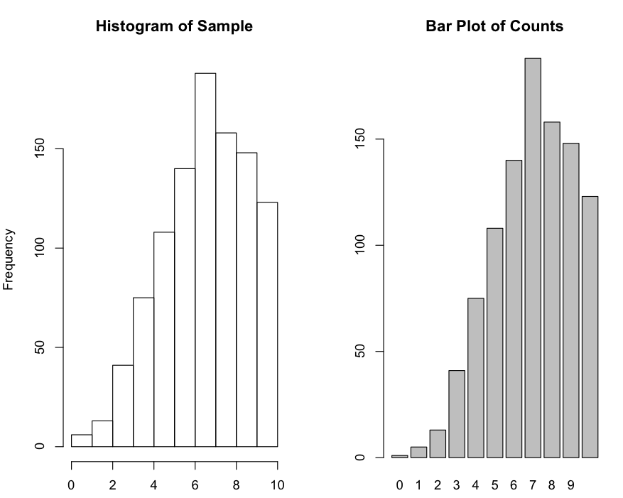

**Simulation Problem 6**

Please find the code below. The function runs without any inputs.

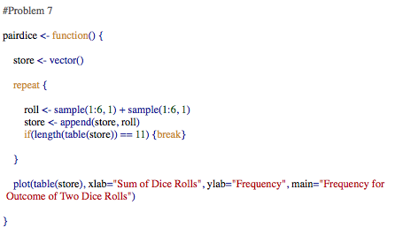

**Simulation Problem 7**

**Part i**

Please see attached scratch paper for calculation of CDF used in code below.

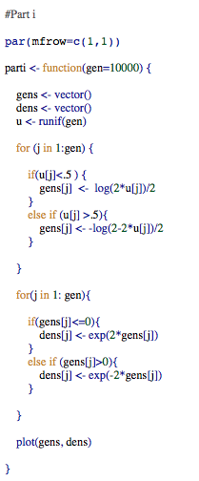

Here is the plot of the pdf produced by the simulations of the function.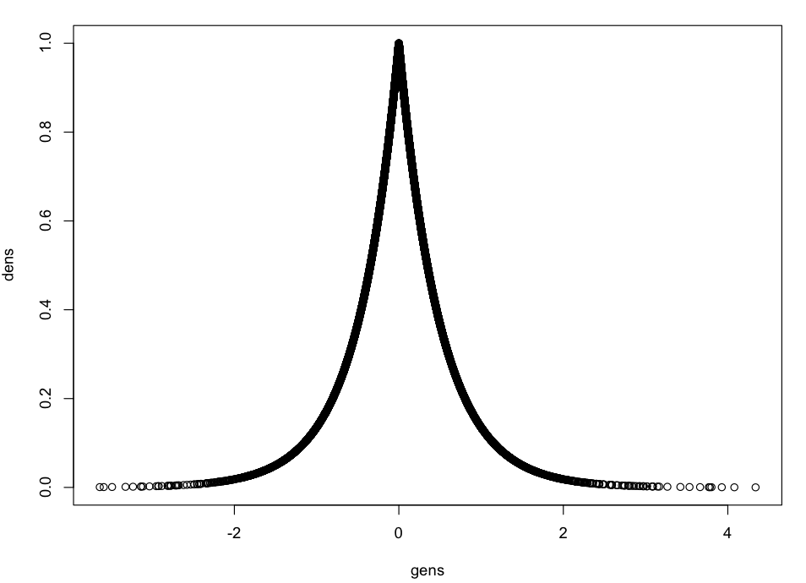

**Part ii**

Please see attached scratch paper for calculation of CDF used in code below.

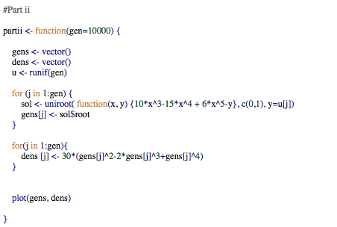

Here is the plot of the pdf produced by the simulations of the function.

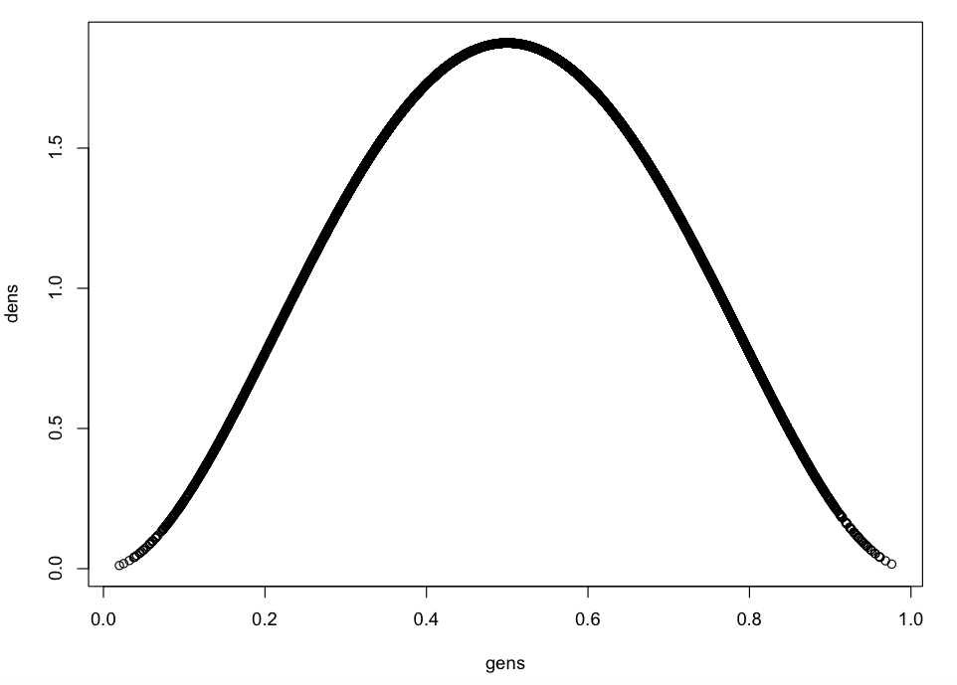

**Part iii**

Please see attached scratch paper for calculation of CDF used in code below.

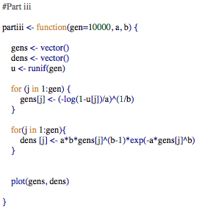

Here is the plot of the pdf produced by the simulations of the function.

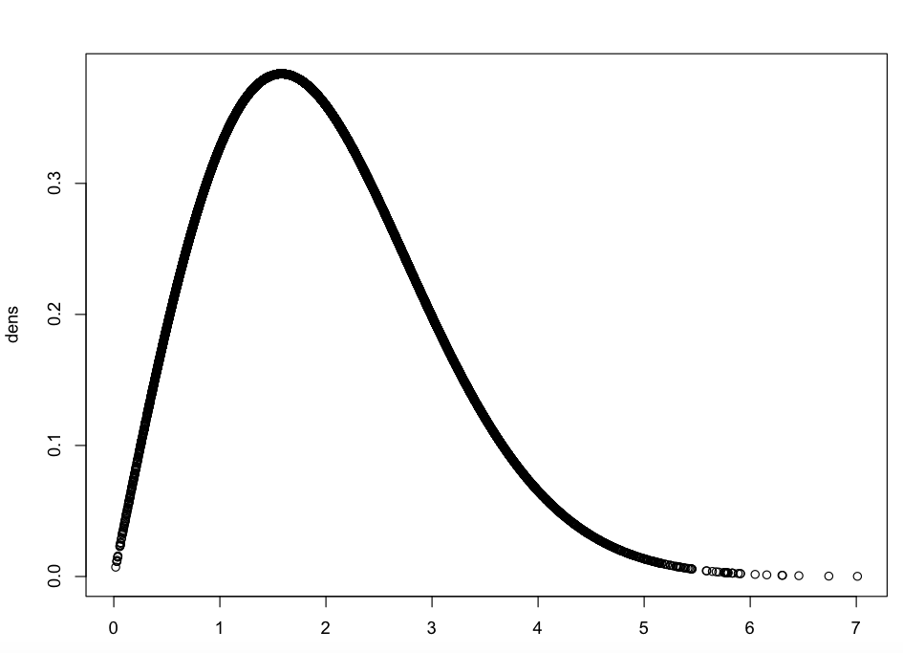

**Simulation Problem 8**

**i.** The approximate covariance from simulation equals -0.05933965. The code for this approximation is shown at the end of this problem.

**ii.** The approximate covariance from simulation equals - 0.06542244. The code for this approximation is shown at the end of this problem.

**iii.** The approximate covariance from simulation equals 0.1407974. The code for this approximation is shown at the end of this problem.

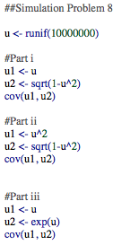

**Simulation Problem 9**

The following is the code for the requested function. I was having trouble running ggplot within the function so I left it outside the function, which you will see in part a, b, and c of iv. The function checks if p1 and p2 equals 1, plots the mixture density, and simulates r realizations.

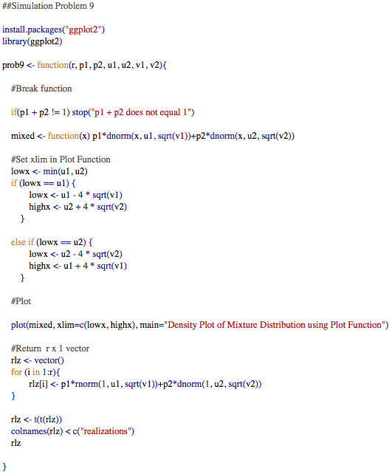

**Part iv**

1. The following code was run.

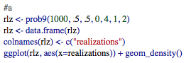

The function of the code produced the 1000 realizations and the following plot.

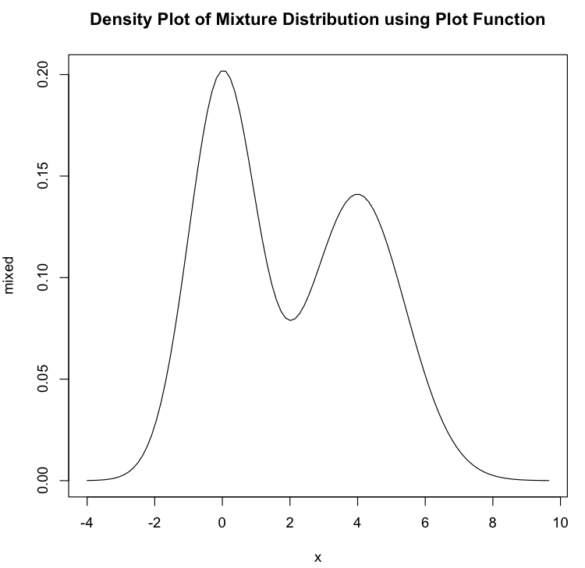

1. The following code was run.

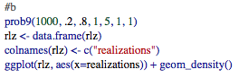

The function produced the 1000 realizations and the following plot.

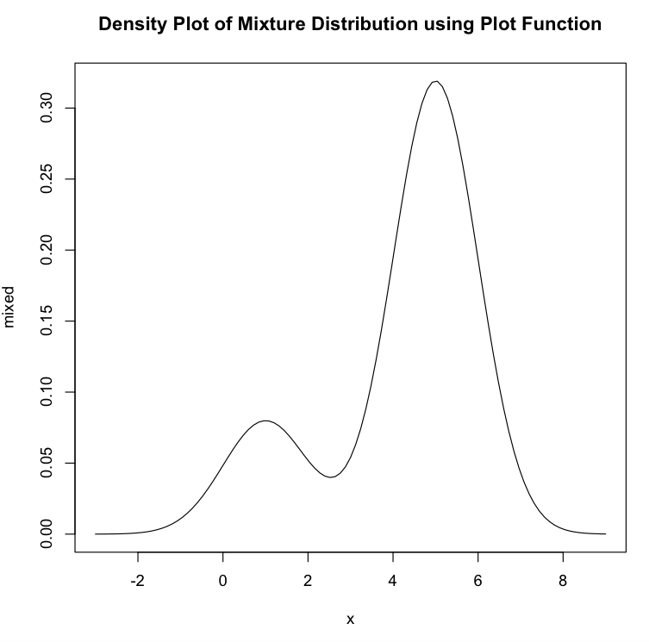

1. The following code was run.

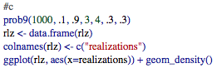

The function produced the 1000 realization vector and the following plot.

